PROJECT DESIGN

Phase-1 Solution Architecture

|  |  |
| --- | --- |
| Date: | 1 October 2022 |
| Team ID: | PNT2022TMID31899 |
| Project Name: | IOT BASED CROP PROTECTION SYSTEM FOR AGRICULTURE |

Cellular tower



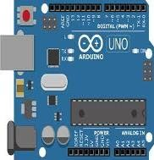Arduino Micro controller

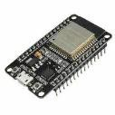

**Now I can monitor my farm from anywhere at anytime**

Gate way module

Internet Cloud

Router

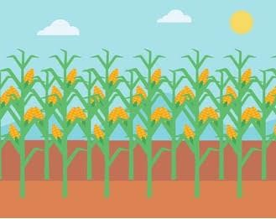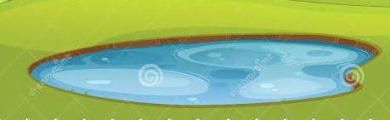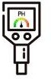

**Camera module**

**Temperature**

**sensor**

**Flame sensor**

**PH level sensor**

**Water and**

**moisture level sensor**

**Motor Pump**

